Solution Assessment Report



Final Report

Prepared for

Update [Customer Name] in doc properties

22-May-15

Version Final

Prepared by

Contributors

**[Contributors]**

Revision and Signoff Sheet

Change Record

|  |  |  |  |
| --- | --- | --- | --- |
| Date | Author | Version | Change Reference |
|  |  |  |  |
|  |  |  |  |
|  |  |  |  |

Reviewers

|  |  |  |  |
| --- | --- | --- | --- |
| Name | Version Approved | Position | Date |
|  |  |  |  |
|  |  |  |  |
|  |  |  |  |

Table of Contents

1 Executive Summary 6

2 Vision for SharePoint 7

2.1 Cloud ready 7

2.2 Agility for business 7

2.3 Cost efficiency 8

2.4 Customize for business value 8

3 High level schedule 8

4 Supporting work streams 9

4.1 Modern responsive apps 9

4.2 App Developer guidance 9

4.3 Environments and ALM 9

4.3.1 Current environment and challenges 10

4.3.2 Future recommended architecture 12

4.4 Provider hosted app hosting 14

5 SharePoint Assessment report 16

5.1 FTC solutions analyzed 16

5.2 Provisioning 16

5.2.1 Customer requirements 16

5.2.2 Considerations and workarounds 16

5.3 Branding 17

5.3.1 Customer requirements 17

5.3.2 Considerations and workarounds 17

5.4 UX Components 17

5.4.1 Customer requirements 17

5.4.2 Considerations and workarounds 17

5.5 Search 17

5.5.1 Customer requirements 17

5.5.2 Considerations and workarounds 18

5.6 Composite and Business apps 18

5.6.1 Customer requirements 18

5.6.2 Considerations and workarounds 18

5.7 Profile enrichment 18

5.7.1 Customer requirements 18

5.7.2 Considerations and workarounds 18

5.8 Web Content Management 19

5.8.1 Customer requirements 19

5.8.2 Considerations and workarounds 19

5.9 Enterprise Content Management 19

5.9.1 Customer requirements 19

5.9.2 Considerations and workarounds 19

5.10 Other 19

5.10.1 Customer requirements 19

5.10.2 Considerations and workarounds 20

1. Executive Summary

Update below text to match your customer needs

The Contoso Solution Assessment was approached from multiple angles. The primary purpose of the assessment was to analyze how the future Office 365 Single Tenant environment complies with the current business and technical requirements. As part of the assessment, Contoso’s SharePoint vision was clarified and recorded as a guidance for the roadmap planning.

Contoso SharePoint Vision statements guiding the future planning and model for SharePoint usage.

* *Cloud ready*
  + Processes, customizations and models created for Contoso have to be cloud ready. This means that the customizations should work in both public and in private cloud.
* *Agility for business*
  + Platform needs to be agile enough to be able to cater to the needs and requirements of the business. This means that, for instance, releasing new independent Internet facing sites should happen in matter of days, not in weeks or months.
* *Cost efficiency*
  + Configure before customizing. Minimize maintenance and operational costs by reducing unnecessary complexity.
* *Customize for business value*
  + Create clear business cases for each customization to ensure that the value is worthy of the investment (ROI). Analyze the short and long-term impact.

In order to support the transformation from full trust code to the app model, we will discuss four supporting work streams in detail.

* Modern responsive apps
* App Developer guidance
* Environments and ALM
* Provider hosted app hosting

1. Vision for SharePoint

Update below text to match your customer needs

The following picture defines the high-level principles of the Contoso SharePoint Vision. These principles drive the transformation from full trust code solutions to the app model.

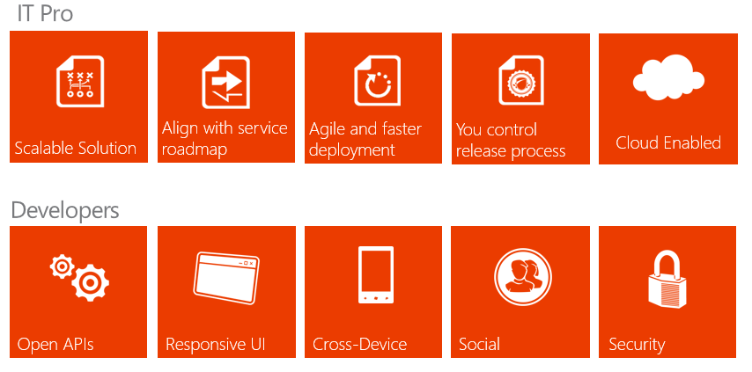

* 1. Cloud ready

All solutions and functionalities should be designed so that they can be supported in both the private and public clouds. This provides flexibility with the hosting platform and deployments are not bound to a single platform in the future.

Customizations developed for Contoso platform should be in line with the SharePoint product roadmap to ensure agility for the deployments. By using the app model as the customization pattern, changes can be applied to sites without the constant need of IT personnel to perform detailed testing.

* 1. Agility for business

App model will result in faster deployments. All projects should aim to minimize complexity, concentrate on the primary objectives, and then offer the actual business functionality in the simplest possible way.

App model supports deployments of new sites and elements to site collections without any downtime. This model reduces the service and maintenance windows.

* 1. Cost efficiency

Minimize the unnecessary complexity involved with customizations if they do not provide direct business value. Use out of box features as far as possible.

Each required function should be evaluated against the value gained and the cost associated with the development and maintenance phase.

Minimize on-premises investments in SharePoint and gradually eliminate the need for the on-premises deployments in favor of cloud options.

* 1. Customize for business value

Each customization and project should have a clear business case (ROI) taking into account short and long-term costs associated with development, training and maintenance.

Out-of-the-box functionalities should always hold priority and customization should only occur if out of the box functionalities or apps from public market place cannot provide similar functionality.

Use the app model whenever possible to minimize operational impact of the customizations and to provide flexibility with the hosting options.

1. High level roadmap

Update below text and schedule to match your customer needs

The following picture defines the high-level schedule for the individual supporting work streams in the Contoso SharePoint environment based on current information.

These schedules are high-level estimates on the time frame:

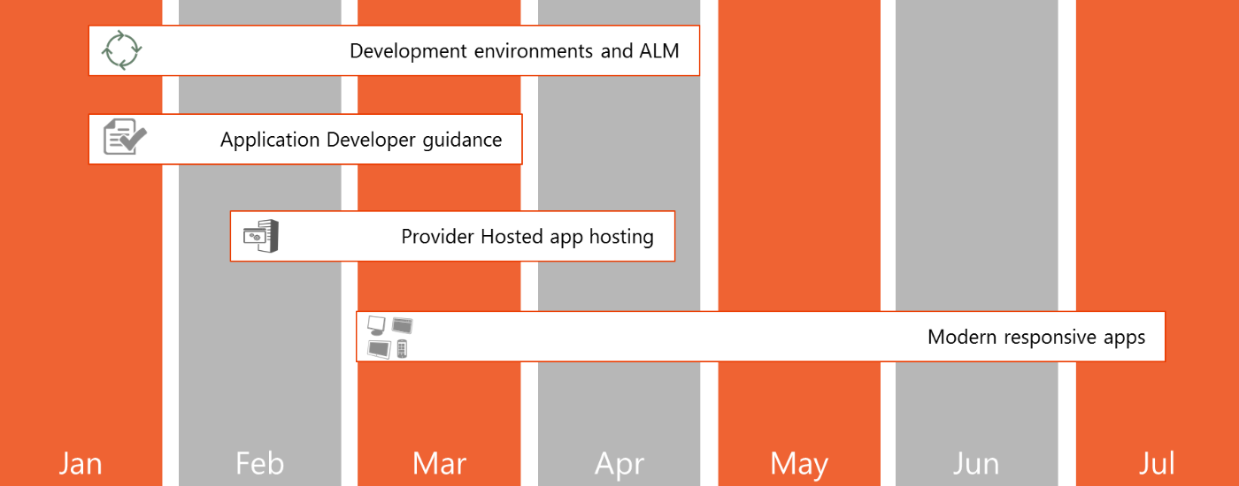

More detailed phasing and area content is available in the next chapters.

1. Supporting work streams

Add introduction

* 1. Modern responsive apps

Describe how the customer can embrace modern responsive apps while doing the FTC to app transformation.

* 1. App Developer guidance

Describe what development options the customer can choose from with their pros and cons. Make sure you emphasize provider hosted apps as a preferred choice.

* 1. Environments and ALM

Add an introduction and modify as required to meet your customer requirements.

* + 1. Current environment and challenges

The Contoso SharePoint environment follows a complex development process, which is causing significant costs in the short and long term. The overall environment consists of several different SharePoint environments that have to be individually maintained and managed on top of the application life cycle management activities.

Based on discussions, one of the key concerns is that Contoso is the centralized hub for vendors working in this environment, which means that Contoso has to perform the required coordination and task management. This has resulted in a situation where Contoso has outsourced the SharePoint development to 3rd party vendors, but at the same time Contoso needs to have highly skilled SharePoint resources available for overall coordination of the operation and customization activities.

With all the incoming change requests, maintenance of the infrastructure is turning out to be a costly proposition.



Currently all source code is stored in centralized TFS farm located in the Contoso corporate network. This means that on-site connectivity is fairly simple, but outside access to TFS requires specific VPN connectivity to the corporate network. This VPN requirement means that each vendor working with Contoso will require access to Contoso network, to access the source code.

Management and operations are also performed by Contoso or assigned partners in addition to the OS and solution patching.



* + 1. Future recommended architecture

The future model is recommended to be more non-Contoso centric where Contoso gets the development, testing and application life cycle management as a service from third party vendor, without taking actual ownership of the environment and coordination.

This model would provide Contoso a way to focus on actual functionality and business requirement coordination, rather than ownership of the environments.

There could still be a need for occasional training or test environments for Contoso staff, hence, Contoso needs to adopt agile farm provisioning only for the given time period or by providing Contoso staff access to farms owned by 3rd party vendors.



Since Contoso has a growing number of vendors who might require TFS access, the more suitable and cost efficient option for TFS hosting is to use the TFS online.

In this setup, external partners can access the same source code as Contoso employees as long as they have Internet connectivity. Similar to an on-premises TFS installation, TFS service supports not only source code, but also task management, test execution and continuous builds.



* 1. Provider hosted app hosting

Add an introduction and adjust below sample text to meet your customer requirements.

Provider hosted environments are required for running complex operations with the app model approach. This environment consists of two to three Windows 2008 R2 or Windows 2012 servers, which are load balanced and have the web role enabled on them.

Actual provider hosted applications are asp.net applications, which can connect back to the SharePoint side on behalf of the user to perform any required actions.

The same environment can also be used for Intranet and Internet facing sites, depending on the network routing.

The illustration below shows the overall architecture with Intranet and Internet platforms sharing the same provider hosted applications. Provider hosted environments can be running either in the private cloud or in the Windows Azure as IAAS or PAAS service, as long as server side code has network level access to the SharePoint deployment.



Remote connectivity between the provider hosted apps and SharePoint farms is secured by Azure ACS registration or certification level authentication on each SharePoint farm.

1. SharePoint Assessment report

Write a short introduction that explains how this chapter is structured and why we have done this exercise.

* 1. FTC solutions analyzed

Describe which FTC solutions were in scope and have been analyzed in detail. Also, describe how the analysis was done and refer to the generated SPCAF (SharePoint Code Analysis Framework) reports.

Note that in the next chapters you will need to discuss the customer requirements and the equivalent FTC analysis grouped per scenario. If a particular scenario does not apply to the customer then just remove that chapter.

* 1. Provisioning
     1. Customer requirements

Describe the requirements the customer has listed for provisioning.

* + 1. Considerations and workarounds

Describe the potential issues you have detected while analyzing the FTC code. It is important that both the Microsoft Partner and the customer have a good understanding of these. If possible, list potential workarounds for these issues: changing the requirements could sometimes be a solution or there could be a technical workaround. When there’s NO solution found then clearly mark this as a “FTC to App blocker” which would require further follow-up.

* 1. Branding
     1. Customer requirements

Describe the requirements the customer has listed for branding.

* + 1. Considerations and workarounds

Describe the potential issues you have detected while analyzing the FTC code. It is important that both the Microsoft Partner and the customer have a good understanding of these. If possible, list potential workarounds for these issues: changing the requirements could sometimes be a solution or there could be a technical workaround. When there’s NO solution found then clearly mark this as a “FTC to App blocker” which would require further follow-up.

* 1. UX Components
     1. Customer requirements

Describe the requirements the customer has listed for UX components.

* + 1. Considerations and workarounds

Describe the potential issues you have detected while analyzing the FTC code. It is important that both the Microsoft Partner and the customer have a good understanding of these. If possible, list potential workarounds for these issues: changing the requirements could sometimes be a solution or there could be a technical workaround. When there’s NO solution found then clearly mark this as a “FTC to App blocker” which would require further follow-up.

* 1. Search
     1. Customer requirements

Describe the requirements the customer has listed for search.

* + 1. Considerations and workarounds

Describe the potential issues you have detected while analyzing the FTC code. It’s important that both the Microsoft as the customer do have a good view on these. If possible, list potential workarounds for these issues: sometimes slightly changing the requirements can be a solution or there can be a technical workaround. When there’s NO solution found then clearly mark this as a FTC to App blocker as this will require further follow-up.

* 1. Composite and Business apps
     1. Customer requirements

Describe the requirements the customer has listed for composite and business apps.

* + 1. Considerations and workarounds

Describe the potential issues you have detected while analyzing the FTC code. It is important that both the Microsoft Partner and the customer have a good understanding of these. If possible, list potential workarounds for these issues: changing the requirements could sometimes be a solution or there could be a technical workaround. When there’s NO solution found then clearly mark this as a “FTC to App blocker” which would require further follow-up.

* 1. Profile enrichment
     1. Customer requirements

Describe the requirements the customer has listed for profile enrichment related requirements.

* + 1. Considerations and workarounds

Describe the potential issues you have detected while analyzing the FTC code. It is important that both the Microsoft Partner and the customer have a good understanding of these. If possible, list potential workarounds for these issues: changing the requirements could sometimes be a solution or there could be a technical workaround. When there’s NO solution found then clearly mark this as a “FTC to App blocker” which would require further follow-up.

* 1. Web Content Management
     1. Customer requirements

Describe the requirements the customer has listed for web content management.

* + 1. Considerations and workarounds

Describe the potential issues you have detected while analyzing the FTC code. It is important that both the Microsoft Partner and the customer have a good understanding of these. If possible, list potential workarounds for these issues: changing the requirements could sometimes be a solution or there could be a technical workaround. When there’s NO solution found then clearly mark this as a “FTC to App blocker” which would require further follow-up.

* 1. Enterprise Content Management
     1. Customer requirements

Describe the requirements the customer has listed for enterprise content management.

* + 1. Considerations and workarounds

Describe the potential issues you have detected while analyzing the FTC code. It is important that both the Microsoft Partner and the customer have a good understanding of these. If possible, list potential workarounds for these issues: changing the requirements could sometimes be a solution or there could be a technical workaround. When there’s NO solution found then clearly mark this as a “FTC to App blocker” which would require further follow-up.

* 1. Other
     1. Customer requirements

Describe the requirements the customer has listed for other areas not covered above.

* + 1. Considerations and workarounds

Describe the potential issues you have detected while analyzing the FTC code. It is important that both the Microsoft Partner and the customer have a good understanding of these. If possible, list potential workarounds for these issues: changing the requirements could sometimes be a solution or there could be a technical workaround. When there’s NO solution found then clearly mark this as a “FTC to App blocker” which would require further follow-up.